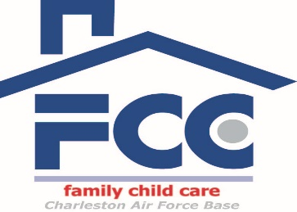

Frequently Asked Questions About What to Expect in a FCC Home

1. How many children can a FCC provider have at one time?
- Six children total, including the provider’s own children under the age of 8 years
- Only 2 of those six can be under 2 years at one time
- Care is typically a mixed age group

2. How old are the children in care?
- 2 weeks to 12 years

3. What goes on during the day?
- Planned activities to promote individual development: social, emotional, physical, cognitive
- Weekly activity plans are posted
- USDA approved meals/snacks served (typically breakfast, lunch and pm snack for day time children)
- Children work on self help skills: cleaning up after themselves, serving their food at meal times

4. Does anyone check on the providers?
- All providers are inspected unannounced monthly by the FCC Coordinator

5. Do they follow State childcare regulations?
- All FCC providers follow Air Force Regulations
- Off base providers follow AF and State regulations
- AF regulations are more stringent than State regulations

6. Do all providers offer the same type of care?
- All providers follow the same AF guidelines
- Providers are individuals, so may offer different types of activities
- It is recommended that you interview more than one provider (if available) to see which meets your child’s needs the best

