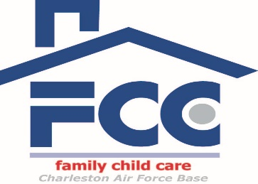

Frequently Asked Questions About Becoming a Family Child Care Provider

1. What are the minimum requirements to become a FCC Provider?
- must be at least 18 years old
- have a high school diploma/GED
- have the ability to read, speak, and write English
- physically, mentally capable of providing childcare
- able to complete the required training
- successfully complete background screenings and home inspections
- live within 15 miles of JB Charleston
- applicants living off base must be registered with the State of SC to provide childcare in their home

2. How long does it take to become a certified provider?
- Time varies depending on when the next licensing class is, but could be as little as 6 weeks

3. What background screenings are completed?
- For all household members 12 years and up: Security Forces, Family Advocacy, Mental Health
- For all household members 18 years and up: screenings listed above plus FBI fingerprints
- All required background screenings must be completed prior to attending the certification class
- All screenings are completed annually

4. If I live on the installation in base housing, do I have to be certified to provide child care?
- Anyone providing care on a regular basis for more than 10 hours per week must be certified. Hours are cumulative: if you care for 4 children one day a week for 3 hours (equals 12 hours of care), then you must be certified.

5. What are the ages of children in FCC?
- Providers may care for children ages 2 weeks – 12 years

6. How many children can I care for at one time?
- Six children total, including the provider’s own children under the age of 8 years
- Only 2 of those six can be under 2 years at one time
- Drop in/hourly children may be cared for (in addition to your full time children) as long as you do not exceed six children at one time

7. Do I need start-up money?
- FCC Program has a Resource Center with all start up materials available at no cost. Items include children’s tables/chairs, shelves, car seats, port a cribs, safety latches for kitchen cabinets, toys, etc
- Liability insurance is required. Currently the company approved by JB Charleston is approximately $415 per year. This is subject to change
- You will purchase food for the first month. Then you will be on the USDA food program and receive a reimbursement for the creditable meals/snacks served to the children

8. How much can I make?
- Currently you will earn $209 per week per each full-time child. Parents will pay a portion of this fee and Air Force will pay the remaining fee.
- Additional income is possible through the many “free” childcare programs AF offers. These programs are paid at $10 per hour. Programs include PCS care, deployment care, military spouse appointment care and care during Reserve drill weekends

9. Does anyone visit my home when I provide care?
- Your home is subject to monthly unannounced inspections from the FCC Coordinator. You are provided copies of the checklists and they will be explained during the certification class. It is your responsibility to maintain the requirements in your home
- Additional inspections may be conducted during the annual fire/health/safety comprehensive inspections, multidisciplinary inspection, and higher headquarters’ inspections. All inspectors use the same inspection checklists provided in the certification class.

10. Is there additional required training after the certification class?
- CPR/First Aid class-prior to certification and then every 2 years (no cost)
- 24 hours of annual training required to renew your certification (provided monthly at the FCC office in the evening at no cost)
- Virtual Lab School (online) —15 modules. One required each month after becoming certified (no cost)

